Views images to get a sense of your business.✴

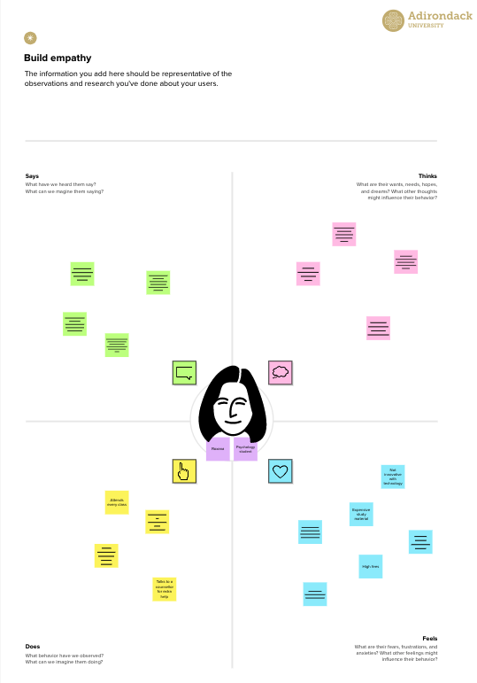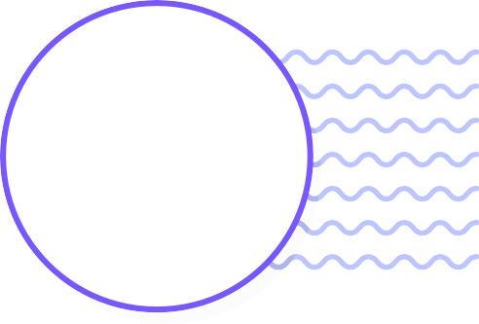

**Compares the quality and quantity of reviews.**



**Discovering your offerings can create excitement and a desire to visit**.

**Build empathy**

The information you add here should be representative of the observations and research you've done about your users.

Empathy map

# Use this framework to develop a deep, shared understanding and empathy for other people. An empathy map helps describe the aspects of a user's experience, needs and pain points, to quickly understand your users’ experience and mindset.

### Says

What have we heard them say? What can we magine them saying?

### Thinks

What are their wants, needs, hopes, and dreams? What other thoughts might influence their behavior?

**Forms an opinion based on reviews and ratings.**

**Evaluates if your business meets their needs.**

**May recommend or warn friends or family.**

**Writes feedback based on their experience.**

|  |
| --- |
| **Talks about your business on social media or other platforms.** |
|  |
|  |
|  |
|  |

**They may recommend your business to others or share their concerns.**

**Considers how easily they can find the information they need.**

**Thinks about the reputation and image of your business.**

**Google My Business Profile**

**Looks for your business details, including, location, hours, and contact information.**

**Positive reviews invoke trust, and trust is a powerful emotion.**

**Views images to get a sense of your business.**

**Sees if there are any recent updates or posts on your profile.**

**Finding easy access to your contact information offers comfort and security.**

**They hope to find not just information but an experience.**

[**Share template feedback**](https://muralco.typeform.com/to/CiqaHVat?typeform-source=app.mural.co)

### Does

What behavior have we observed? What can we imagine them doing?

### Feels

What are their fears, frustrations, and anxieties? What other feelings might

influence their behavior?

**Template**

**Need some inspiration?**

See a finished version of this template to kickstart your work.

[**Open example**](https://app.mural.co/template/f44b7843-7c23-408c-bd36-7b0c9409dc20/96efd10c-81d2-401e-8072-4e87935e5d6b)